Green University of Bangladesh

Department of Computer Science and Engineering
Lab Final Assessment, Fall 2023

Course Title: Microprocessor and Microcontroller Lab

Total: 30 Time: 1 hr.

1 | 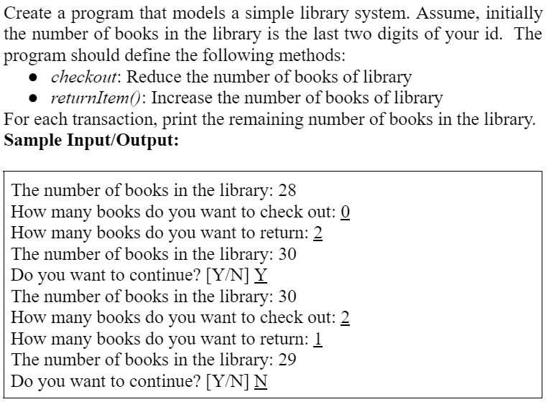 | 10
2 | 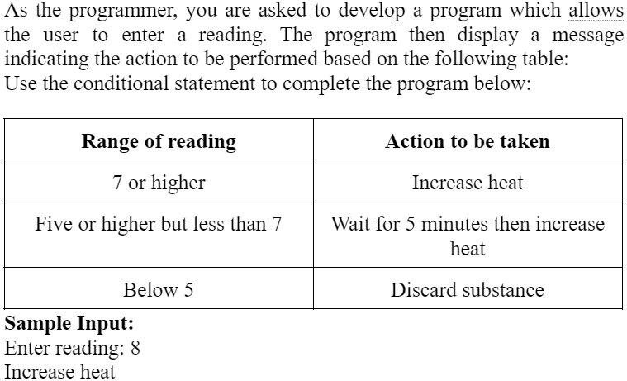 | 10
3 | 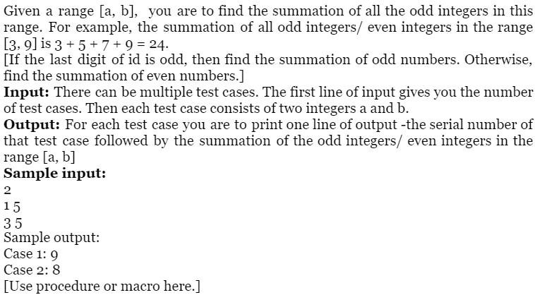 | 10

